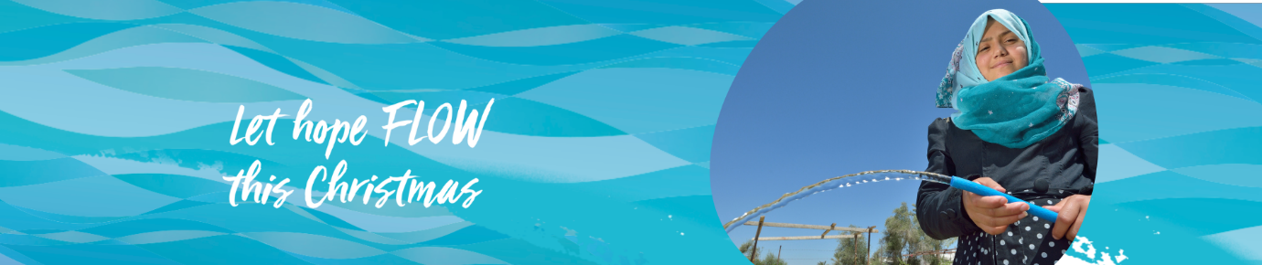
Facing the Climate Challenge with Peace
In the land where Jesus was born, water is a precious resource that many are finding harder to access. The climate crisis makes the situation worse for families struggling to get the water they need to keep families healthy and well. In October, the World Council of Churches told the story of Im Omar (not pictured), a 31 year old mother of six and a small Bedouin farmer who lives near Tequoa in Bethlehem’s Area C of the West Bank.
The family run sheep and camels but struggle to provide the water they need.
“Livestock is our main source of livelihood, so we must find water all the time,” she tells the WCC.
Now days the family keeps them in the shade so they stay cooler. In the past, the animals were free to roam. At times they have to buy the remains of pressed grapes from the wine distilleries in Bethlehem to keep them hydrated.
“We cannot let the livestock die of thirst, especially during the summer when the weather is hot and dry,” says Im Omar. “When we are talking about the livestock, we are talking about the means that provide our children with food.”
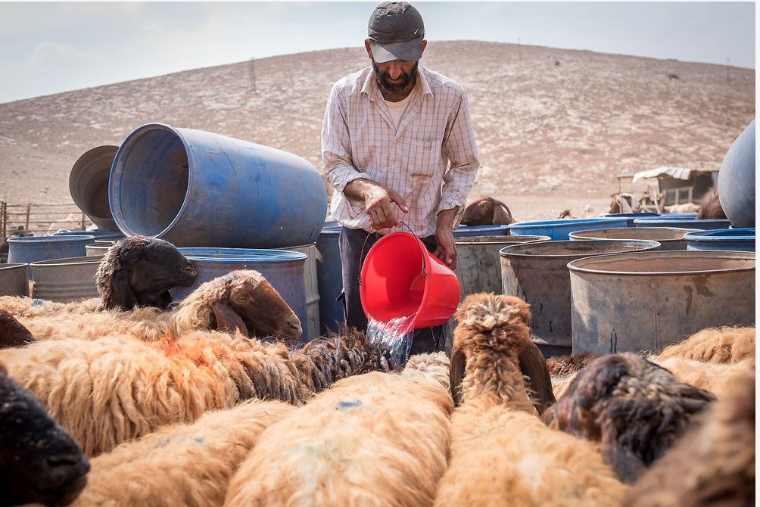
The wells were dug 56 years ago to support the Jordanian army, but the community has not been allowed to dig the new wells they urgently need even though they have applied to the Israeli authorities who control the water supply. She says they have had no response. Fortunately, international help gave them some resources to carry out some minor repairs but it is not enough.
“We go individually to buy water, because we do not want our children to die of thirst,” says Im Omar. “Providing water is a daunting task, first and foremost because we lack storage tanks; ours are old and very small.”
“Sometimes the men must drive long hours, and it is a dangerous endeavour because of the Israeli military patrols in the desert,” she says. “There were incidents when the men were attacked by soldiers and our cars confiscated.”
Im Omar does not want to give up her home; she just wants to find enough water for her family. “There are Bedouin families who gave up due to the tremendous shortages we endure in the community,” she reports. “They had no choice other than to sell their livestock and to become farm labourers somewhere else.”
In Area C where Im Omar lives, more than 150,000 Palestinians live in over 540 communities, 200 of which continue to suffer from a severe shortage of clean water.
Throughout the West Bank, Palestinians are allocated around 70 litres of water per capita per day. According to the World Health Organization, people require a minimum daily water allotment of between 100 and 120 litres to maintain the most basic standard of living. Israeli settlers in the West Bank consume as much as 800 liters per day.
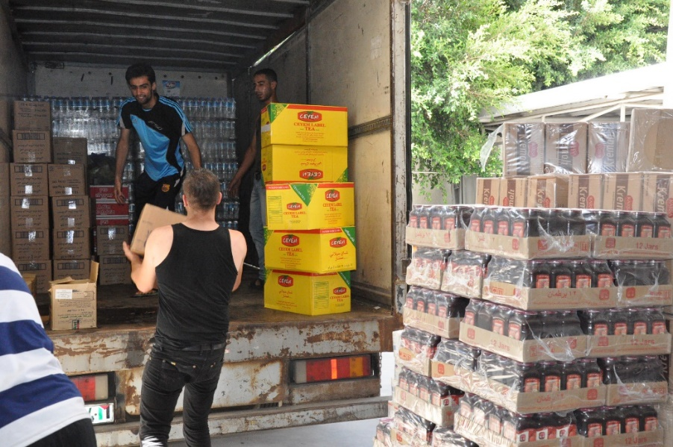
In Gaza
As hard as life is on the West Bank, the situation is worse in Gaza. The 41 kilometre long strip is now home to more than two million people. The borders are tightly controlled, and residents have experienced four major conflicts since 2007, leaving thousands dead, homes destroyed and most of the population traumatised. The World Bank reports only 1% of its people have access to safe water. Water comes from the coastal aquifer but there is less and less rain to replace it. With two-thirds of the population living below the poverty line, many people cannot afford to buy water.
The Department of Service to Palestinian Refugees belongs to the people and is a strong advocate for peace and an end to the occupation. It uses its skills and networks to support people living in Gaza, the West Bank, Galilee, Jordan and Lebanon to access their rights to water, education, healthcare and improve livelihoods where they can. The challenges are immense, but they build strong communities so people can support each other despite the trauma and deprivation.
DSPR was part of a process that led to the Kairos Document, a statement by Palestinian Christians about their situation.

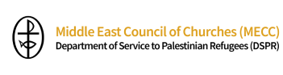
When the first Palestinian refugees were expelled from their homes in 1948, local clergy and lay people set up an ad-hoc committee to help. Nearly eight decades later DSPR is made up of area committees in Gaza, Jerusalem and the West Bank, Jordan, Lebanon and Nazareth.
DSPR:
• Builds community between refugees and local people
• Runs five primary health clinics in Gaza and Jordan, focused on mothers and children and including trauma and psychosocial care
• Runs schools and education programmes from preschool to adult literacy classes and vocational training programmes
• Organises safe transit for Syrian students to return to Syria to sit High school exams
• Supports start-up businesses, especially for women and young people
• Funds water projects
• Provides emergency assistance
• Advocates for the rights of Palestinians and refugees.

“Amidst all this we, in DSPR MECC believe in our work and we see it as part of the resuscitation of our societies. We persevere thanks to our staff members across five different Areas and in the Central Office. We persevere thanks to our partners who hold hands with us and never relent in their support. We persevere because the alternative is to accept realities that need to change.”
Dr Bernard Sabella, Executive Director.

Service to Palestinians: Signs of Hope Against Despair
A mixture of feelings is evoked when going through the [2021] annual report of the Department of Service to Palestinian Refugees of the Middle East Council of Churches.
• a feeling of pain in the light of what the Palestinian people have been going through for three quarters of a century,
• a feeling of frustration, since this sister population, is our neighbor living near to our homeland, with common families and relatives in both countries, and we are unable to go to them, and vice versa,
• a feeling of helplessness since we are unable to rescue them from the oppression they experience daily,
• a feeling of injustice in view of the double standards used by parts of the international community which turns a blind eye when it comes to Palestine,
• a feeling of revolt against the attempts to annihilate a whole people, culture and civilization, by violence, by manipulation as well as by deception.
We feel every day that, in the land of Palestine, Jesus Christ is slandered, scourged, carrying His Cross, and walking all the way to His crucifixion. However, on the other hand, we know that after three days, the stone will be rolled down, and Resurrection will prevail.

For more information on the current situation, read Where is Palestine? A story of loss, inequality and failure by William Bell, Christian Aid. Published in September 2021, it includes a section on water.

Images: Thanks to Albin Hillert, ACT Alliance, DSPR and Paul Jeffrey.

