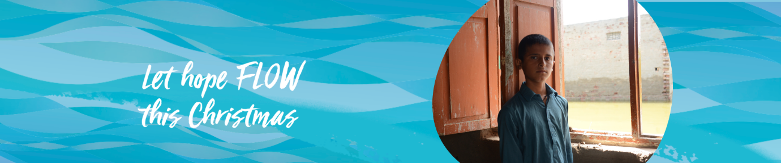
Facing the Climate Challenge with Love

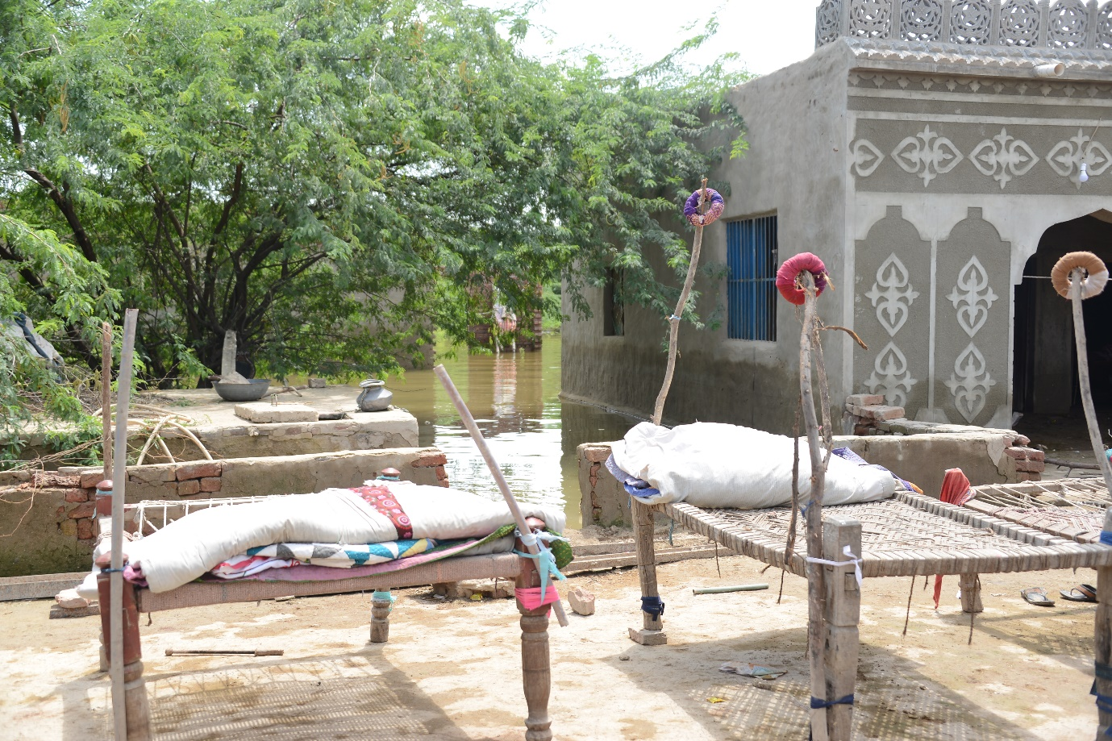

Pakistan reports 33 million people were affected by the floods that covered one third of the country. Months later 1.85 million are displaced from their homes and parts of Balochistan and Sindh provinces remain under water. Community World Service Asia reports the needs of women and children are becoming more critical. Children are suffering from malnutrition, diarrhea, malaria, dengue fever, typhoid, acute respiratory infections, and painful skin conditions. Millions of agrarian communities have lost their homes and livelihoods and have no access to food, shelter, or clean drinking water.
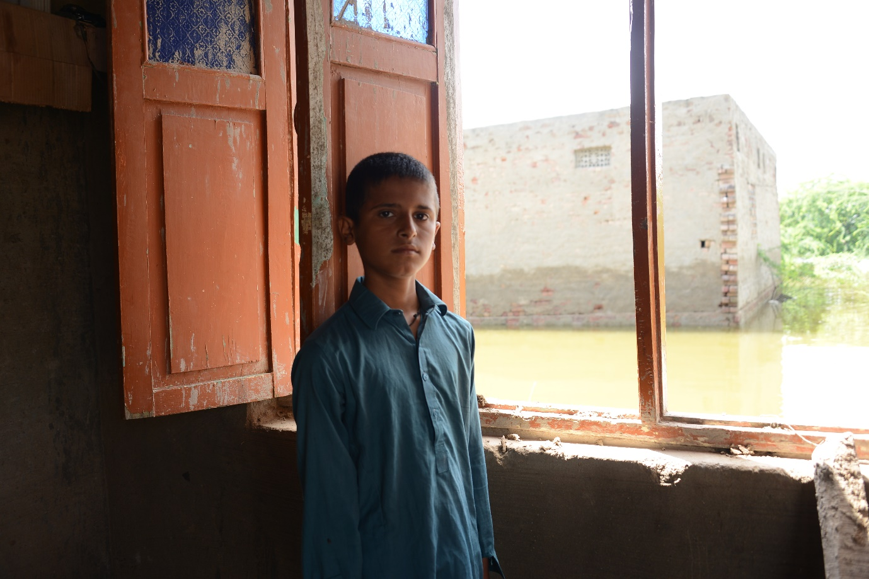
When a rapid assessment team from Community World Service Asia travelled by wooden boat to the village where Luqman and his grandmother live, they were surprised to find anyone home. It was September when the floods were high and much of the region covered in water. They could tell the home was once surrounded by beautiful gardens but now the water reached more than two metres up the wall.
The house was full of women and children from their extended family. As the oldest male in the household, 13-year-old Luqman was responsible for safeguarding the honour of his Baloch family – his grandmother, mother, aunts and their children. The men had evacuated to safer grounds and were living on make-shift shelters on the roadside and the banks of canals where they might access help and relief supplies. Every few days his great-uncle would deliver precious fresh water and supplies – travel was expensive.
Luqman was missing school and told the team that he was in Grade 6 and doing well at school. Excitedly, he took out his last report card and showed it to us with gleaming eyes. The public school for boys in their village has been shut down for two months already. Luqman was missing his friends and even homework. There was no one to play with and hiss mother and grandmother would not allow him to wander off because of the growing number of snakes in the water and the high probability that he would get a skin infection from the contaminated water.
The team had little to share with the family, but they were all pleased to have someone to talk to about what was happening. They were all hoping the water would go down soon. More than anything Luqman wished to have a hot, scrumptious meal – with fresh roti and fully cooked, delicious curry or vegetables. They did not have enough fuel to prepare meals properly and the food did not taste good he said.
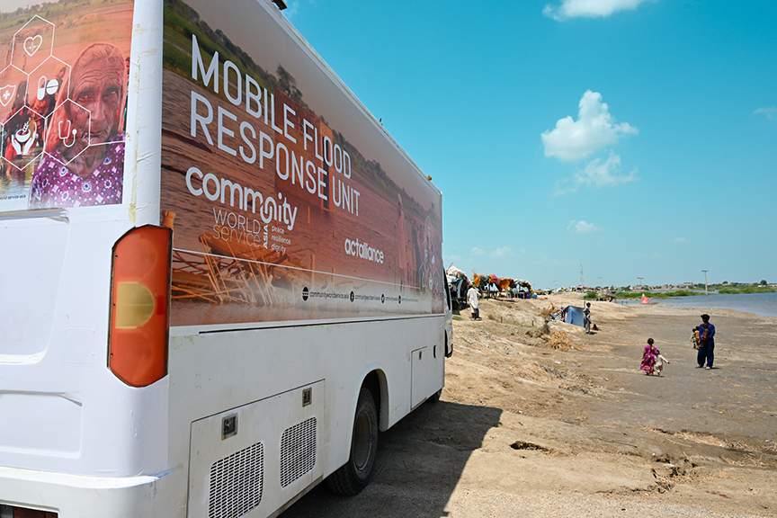
Community World Service is one of CWS partners that responds to humanitarian emergencies. Thanks to your support, we have been able to send funds to provide a regular cash transfer for each of three months to some of the most vulnerable families after the floods. Your donations have also assisted families from Afghanistan. Cash transfers allow families to purchase what they most want and need – it may be food, rent, medicines or something else. It has also deployed its Mobile Health Clinics to provide free medical care to some of the many people with chronic health conditions or who suffer from water-borne diseases like diarrhea and malaria.
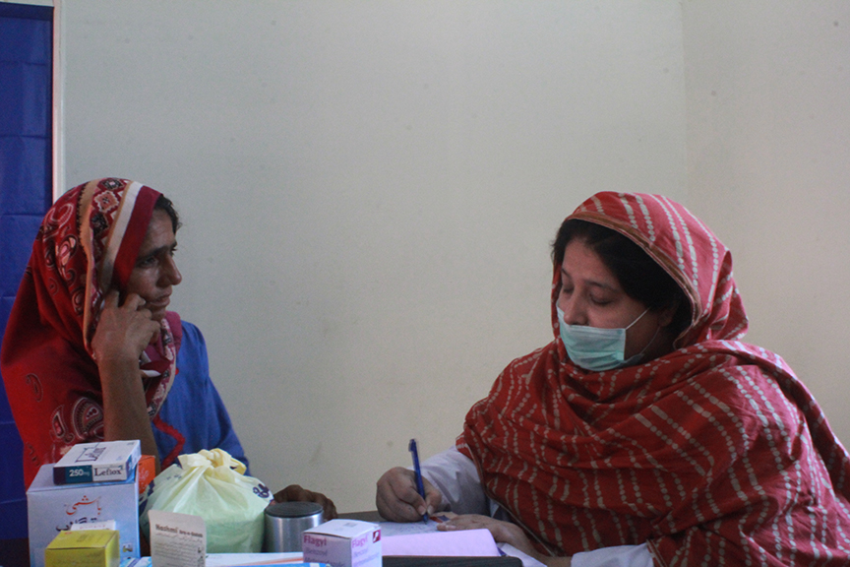
A mother seeks treatment at the Mobile Health Clinic

Community World Service Asia is a humanitarian and development organisation based in Pakistan and has programmes in a number of countries including Afghanistan. It focuses on:
- Responding to Emergencies
- Assisting communities respond to climate change and prepare for the more intense disasters eg teaching communities to build above likely flood levels
- Education for all ages
- Healthcare including Mobile Healthcare Clinics
- Improving Livelihoods
- Providing safe water sources, improved sanitation and teaching good hygiene
- Implementing better quality and accountability programmes that treat the needs of beneficiaries first, including training other NGOs and promoting the Core Humanitarian Standard.

Watch the introductory video: https://vimeo.com/376743170?embedded=true&source=vimeo_logo&owner=6904931
Images: Thanks to Community World Service Asia

