Fiji Emergency Appeal

Cyclone Winston ripped apart homes and livelihoods when it hit Fiji with wind gusts up to 325 kilometres an hour. Those directly in its path are facing a marathon clean-up job. They need help with food until they can replant and harvest crops, and with shelter so they can build back better.

CWS partner the Social Empowerment and Education Programme is helping isolated communities in the interior of Viti Levu with food and shelter. They are organising youth groups to provide psychosocial care for children. The Peoples Community Network will assist in the informal settlements.

Can you help the people of Fiji get through until new crops grow and they can rebuild homes and livelihoods?
YES, I want to help the people of Fiji. 02/16
Enclosed is my cheque for □$30 □$50 □$100 □Other $_____

Mrs/ Mr/Miss/Ms__________________________________________
Address_________________________________City____________
Email________________________ Parish_______________________
□Mastercard □Visa □Diners □Amex $____________
Name on card__________________________ Expiry Date ___/___
Card Number_______ / ________ / ________ / _______

Return to Christian World Service PO Box 22652 Christchurch 8140
Or phone 0800 74 73 72 or go to www.cws.org.nz/donate
Help Fijians with food, shelter and
psychosocial care.
Please donate now.
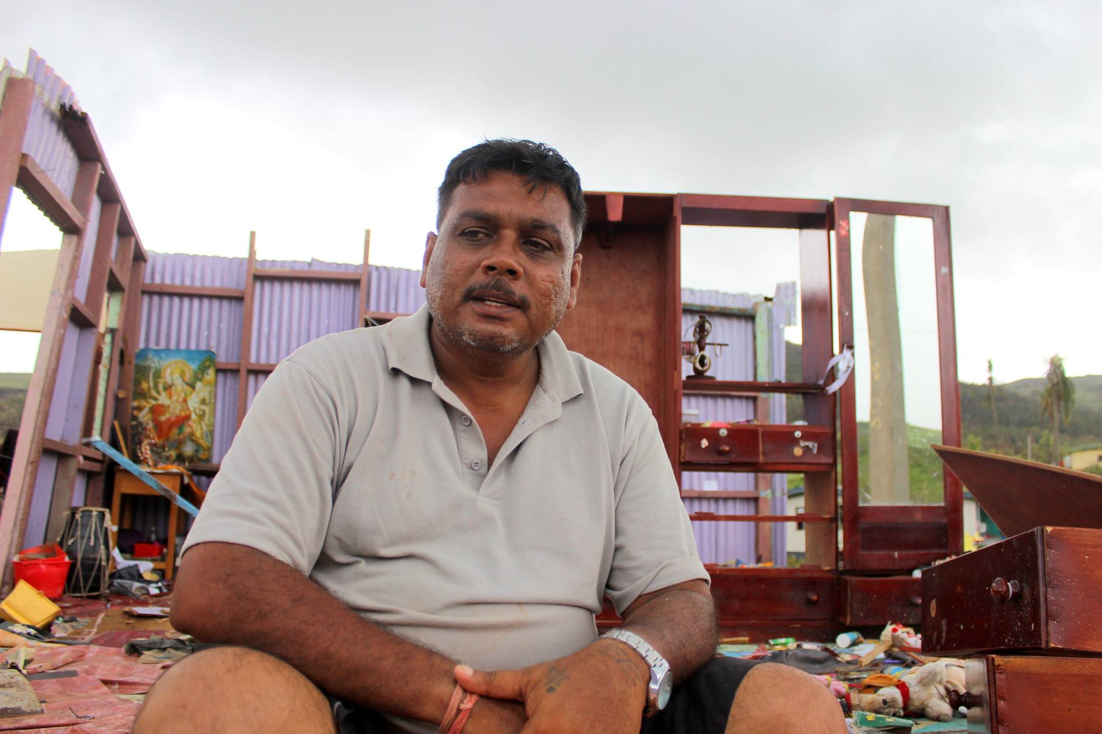
Phoro: Fiji Government
CWS Fiji Cyclone Appeal
CWS Syria Appeal
>>Credit card: phone 0800 74 73 72 or online www.cws.org.nz/donate

>>Direct Deposit: Name of Account: Christian World Service
Account number: 06 0817 0318646 00, ref: Syria
Email your postal details to cws@cws.org.nz if you would like a tax receipt.

>>Post: Christian World Service PO Box 22652 Christchurch 8140
CWS Syria Appeal
>>Credit card: phone 0800 74 73 72 or online www.cws.org.nz/donate

>>Direct Deposit: Name of Account: Christian World Service
Account number: 06 0817 0318646 00, ref: Syria
Email your postal details to cws@cws.org.nz if you would like a tax receipt.

>>Post: Christian World Service PO Box 22652 Christchurch 8140
CWS Syria Appeal
>>Credit card: phone 0800 74 73 72 or online www.cws.org.nz/donate

>>Direct Deposit: Name of Account: Christian World Service
Account number: 06 0817 0318646 00, ref: Syria
Email your postal details to cws@cws.org.nz if you would like a tax receipt.

>>Post: Christian World Service PO Box 22652 Christchurch 8140

>> Credit card: phone 0800 74 73 72 or online www.cws.org.nz/donate

>> Direct Deposit:
Name of Account: Christian World Service
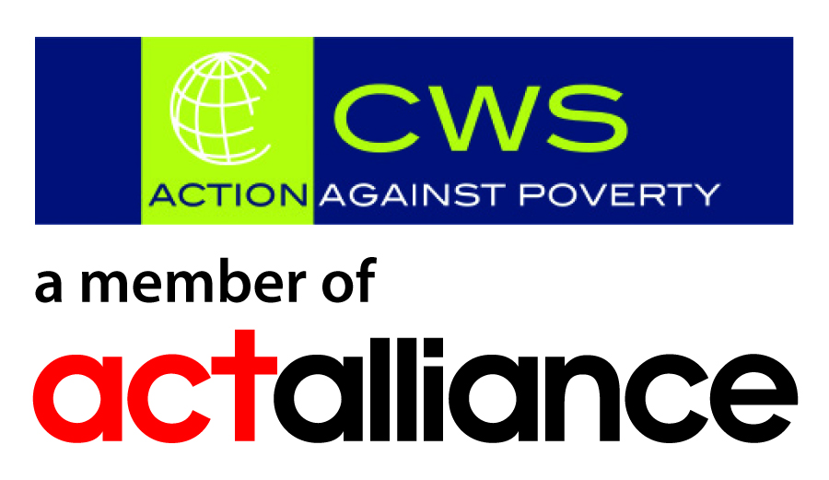
Account number: 06 0817 0318646 00, ref: Fiji
Email your postal details to cws@cws.org.nz if you would like a tax receipt.

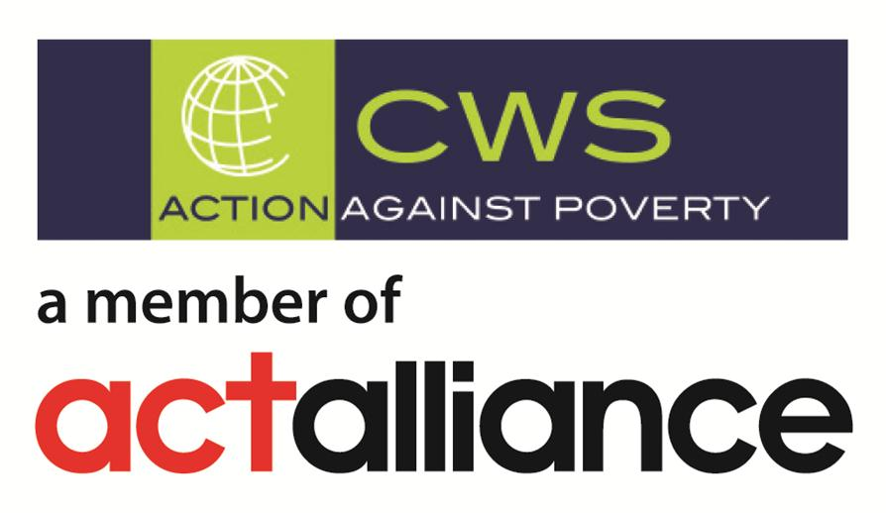
>> Post: Christian World Service PO Box 22652
Christchurch 8140
Christian World Service is a registered charitable entity under the Charities Act 2005 #CC22288

